**Q.1 Design below calculator using HTML and CSS .**

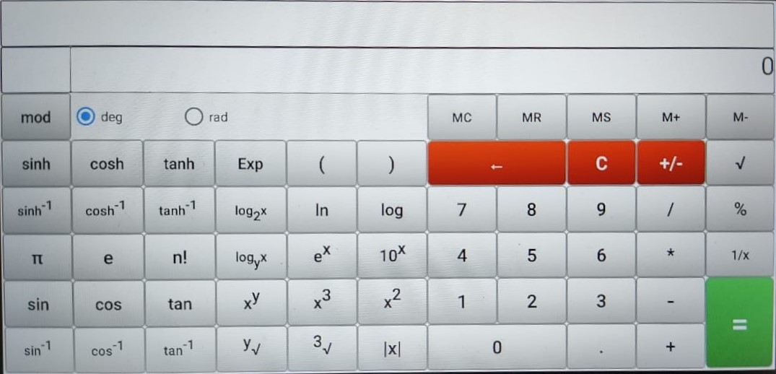

**Q.2** **Design below structure using HTML and CSS.**

**Note – Do not use flex and grid to solve this question.**

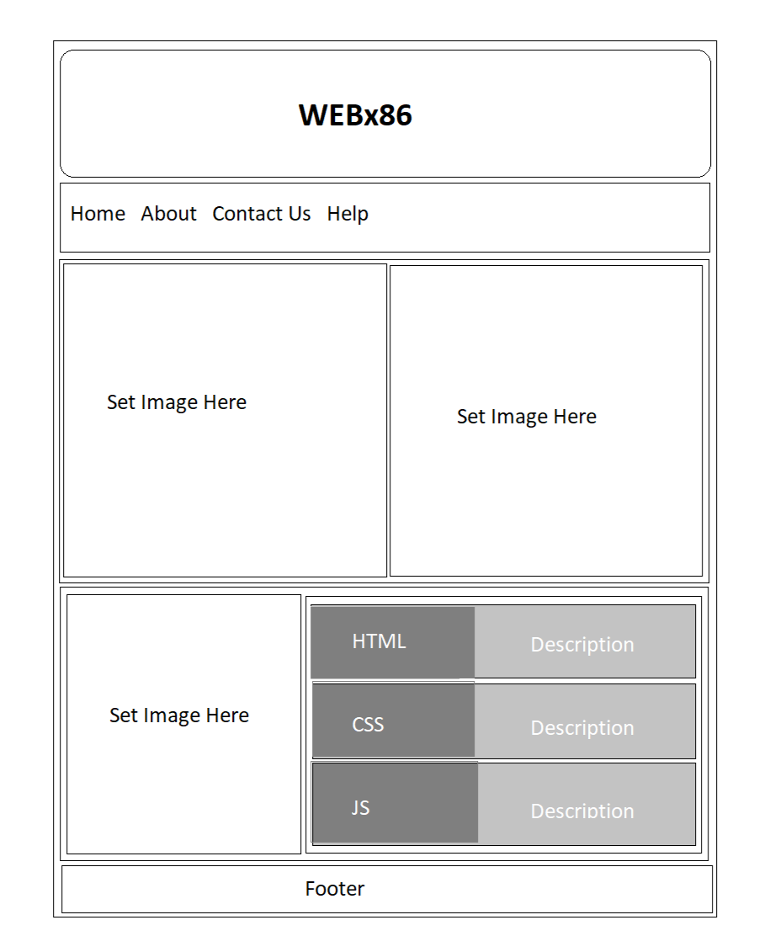

**Q.3 Design webpage using HTML and CSS from wireframes given below. Use colors and images of your choice but it must have some color theme.**

**Note - Do not use flex and grid to solve this question.**

